ADP-CS FINAL PROJECT
Project-1

Ecommerce Website



Project Advisor

M. Umer

Presented by:
Group ID: BZZS-1

Student Reg# S2F23UASCS001
Student Name: Burhan Ahmad

Faculty of Information Technology

University of Central Punjab
Software Requirements Specification

Automated E-Commerce Platform: Enhancing Efficiency and Streamlining Online Shopping
Advisor: M. Umer

Group BZZS-1
Member Name | Primary Responsibility
Burhan Ahmad | Frontend/ Backend
Zain Ali | Frontend
Sameer Ahmad | Frontend
Zeeshan Zahid | UI/UX

Table of Contents
Table of Contents i
1. Introduction and Background 1
1.1 Product (Problem Statement) 1
1.2 Background 1
1.3 Scope 1
1.4 Objective(s)/Aim(s)/Target(s) 1
1.5 Completeness Criteria 2
1.6 Business Goals 2
2. Functional Requirements 3
2.1 Functions of System 3
2.2 Requirements Analysis and Modeling 4
2.3 Usage Scenarios 6
2.4 Adopted Methodology 6
3. Nonfunctional Requirements 7
3.1 Performance Requirements 7
3.2 Safety Requirements 7
3.3 Security Requirements 7
3.4 Additional Software Quality Attributes 7
4. Other Requirements 8
5. Revised Project Plan 8
6. References 8
Appendix A: Glossary 9

Introduction and Background

This is an era of modern times, and it is well known that most of the businesses in this modern world are not found to be going so well without the internet. With the huge increase in online shopping in the wake of the COVID-19 wave, in such a scenario, business houses have to provide their customers with an easy and effortless online shopping experience. However, it is quite tiresome and is prone to a large number of errors and inefficiencies from the lists of products, details of customers, tracking of orders, and payments that are manually monitored. Manual approaches tend to be extremely unreliable and time-consuming; it becomes impossible to scale up with numbers of customers and transactions as they are becoming higher. Therefore, a strong e-commerce site is required for the market demands of today and in the smooth running of business too; automation is aimed for maximum efficiency, reliability, and scalability while avoiding human mistakes and operational complications.

Product (Problem Statement)

Maintaining an e-commerce website without a process is inefficient and error-prone. Companies are busy with inventory management, processing of orders, and customer services, which takes a time of their hands to respond on time and leaves the business running for a bad experience. As such, the need is for an automated e-commerce website to smooth out processes, minimize human errors, and increase satisfaction of users through automation and AI through real-time analytics and personalized recommendation.

Background
E-commerce has changed the retailing world. Businesses can now reach clients around the globe and work without time bounds. However, managing an online store by hand comes with several associated problems like lengthy processes and human error in tracking stocks, processing orders, and customer support. Such shortcomings hinder business growth and satisfactory customer services. Better AI tools to automate operations have emerged. These automation products enhance operational flows, minimize error margins, and provide shoppers with more control over their selections. Creating an automated e-commerce platform in this project aims at operational efficiencies, scalability, and experience in general for a customer.

Scope
The scope of the automated e-commerce website project would be to come up with a platform that automates key business operations, namely, inventory management, order processing, and customer support. In other words, it will involve the real-time tracking of the inventory, automated fulfillment of orders, AI-driven recommendation of products, and the chatbot-based provision of customer support. Further, the sales and analytics dashboard for providing real-time insights would also be included. User account management will be supported. It will provide multiple payment gateways and will be mobile-responsive, secure, scalable, and optimized for SEO so that more people are satisfied with their visit and further business may happen.

Objective(s)/Aim(s)/Target(s)
- Stock Automation: Updating stocks in real-time prevents the occurrence of stockouts but creates probabilities of mistakes.
- Order Processing Efficiency: Self automated Key Confirming of orders transactions association to system for shipment means it's guarantee that the orders will get shipment and delivered as early as it could.
- Customer Experience Improvement: Product recommendation, AI-enabled, also with Chatbots are crucial to ensuring that seamless service is delivered and well-supported by an effective customer care clientele.
- Business Analytic: The central dashboard will also provide you with sales, customer behavior, and marketing performance data in real-time.
- Operational Efficiency: Automate standard procedures throughout the whole platform and save time through a less expensive manual operational process.

Completeness Criteria
- User Experience: The website must be fully seamless and intuitive through any desktop and mobile applications with painless navigation having rapid page-load times and fully responsive to the layout designed.
- Security Features: Payment has been adequately encrypted also secured from the usual attacks of SQL Injection and Cross Site Scripting etc.
- Scalability: High traffic and account handling along with greater transaction can be maintained without noticeable degradation of performance
- Integration Testing: All third-party libraries had been integrated which all were tested working well along with payment gateway shipping services, email services etc.
- Customer Service Automation: This comprises of automatic responses and even chatbots to answer customer queries and also to offer assistance to them.
- Analytics Dashboard: This is an Analytics Dashboard for real-time sales as well as performance. Actually, it might work quite well in actually providing an all-around idea of the business.
- Deployment: It is to be directly deployed in the production environment, hence to be monitored and maintained itself afterward.

Business Goals
The major business objectives of an automated e-commerce website project include operational efficiency through the automation of vital operations such as inventory management, order processing, and customer support that reduces efforts and curbs operational costs. This will offer a more pleasing customer experience in terms of product recommendations as well as an efficient shopping experience with improved chances of conversion rates and retention. This is geared towards helping the business to grow as well as addressing more needs of the market. Here, data analytics and automation can be embraced to improve the process in making business decisions, so that sales performance is enhanced relatively to business growth.

Functional Requirements

Functions of System
- Customer Registration and Management
Login: Only registered customers can log in to the system using their credentials.
Manage Account: The system shall make it possible for customers to modify their personal particulars for example shipping address and contact information.

- Product Browsing and Shopping
Browse Products: The system shall enable a customer to browse product categories and further even see the product detail.
Product Search: The system would allow the customers to search for a product using either its name or category.
Add to Cart: The system would allow customers to add products in their shopping cart.
Update Cart: The system will allow customers to change the quantity of items in their shopping carts or delete them from their shopping cart.
Checkout: Systems allow customers to checkout in order to place orders.

- Order Management
Place Order: The system shall allow customers to place orders by providing payment details.
Track Order: The system shall enable a customer to track his/her orders in real time.
Cancel Order: The system should enable the customer to cancel orders that have not yet processed for shipping.

- Payment Gateway
Make Payments: The system shall allow the customer to make secure payment through the integrated payment gateway.
Validate Payment: The system shall validate customer payments and confirm their payment status.
Refund: If order canceled

Requirements Analysis and Modeling
Use Case Diagram:

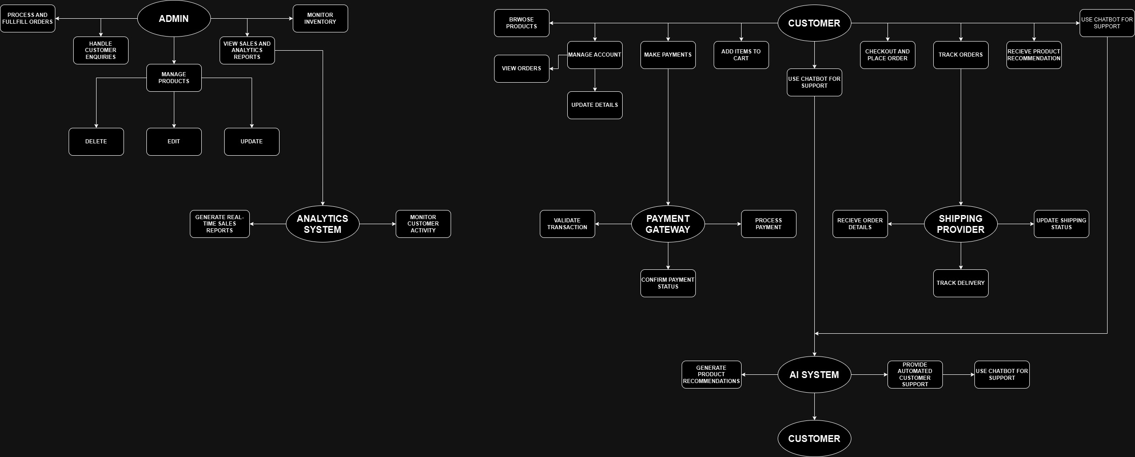

Activity Diagram:

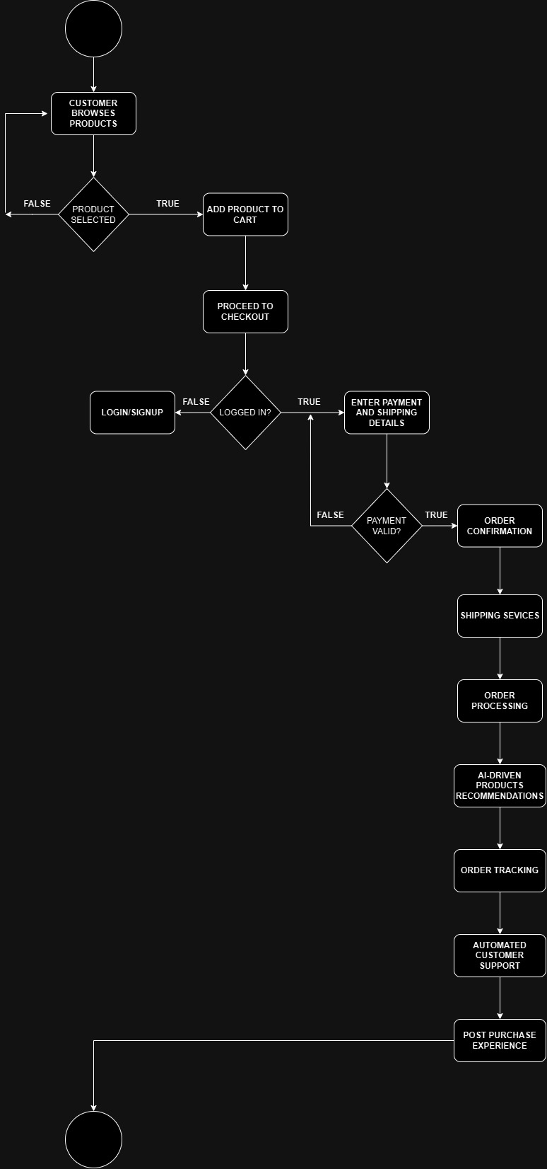
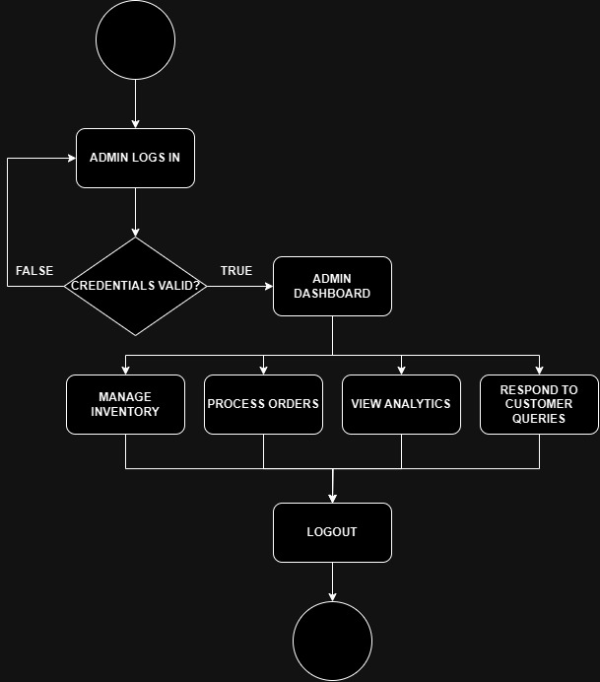
Customer Side: Admin Side:

Usage Scenarios
Scenario | Actors Involved | Description
Browsing Products | Customer | The customer browses through product categories, views product details, and compares items.
Placing an Order | Customer, Payment Gateway, Admin | The customer adds products to the cart, checks out, makes a payment, and receives order confirmation. The admin processes the order.
Order Tracking | Customer, Shipping Provider | After placing an order, the customer tracks the shipment's status through integration with the shipping provider.
Inventory Management | Admin | The admin monitors stock levels, adds new products, updates existing ones, and sets low-stock alerts.
Automated Product Suggestions | Customer, AI System | The system provides personalized product recommendations based on customer browsing and purchase history.
Customer Support | Customer, AI System (Chatbot) | The customer interacts with the automated chatbot for order inquiries, product questions, and issue resolution.
Payment Processing | Customer, Payment Gateway | The customer makes a payment through the gateway, and the system verifies the transaction and updates the order status.
Sales Reporting | Admin, Analytics System | The admin views real-time sales data, customer behavior analytics, and inventory trends through the dashboard.
Account Management | Customer | The customer updates personal details, views order history, and manages shipping addresses from their account.

Adopted Methodology
Agile methodology has been applied for developing an automated e-commerce site. Agile accommodates flexible and iterative development that means constant feedback causes continuous improvement in the process. The projects are then subdivided into the short cycles of time referred to as sprints that takes up features like automating the inventory management, orders processing automation, and so on and customer support automated. Meeting with the stakeholders gives an opportunity of getting through with changing requirements thereby improving the adaptability. This will enable an early functionality prototype, helping to test and perfect the result based on the response from real users. Agile sets objectives in terms of developing flexible and high-quality, user-driven processes while focusing on delivering in relation to business needs.

